



**UNIVERSIDAD AUTONOMA DE NUEVO LEON**

**FACULTAD DE CIENCIAS FISICO-MATEMATICAS**

**LIC. EN MULTIMEDIA Y ANIMACION DIGITAL**

**UNIDAD DE APRENDIZAJE:**

**MODELOS DE ADMINISTRACION DE DATOS**

**AVANCE 2**

**GRUPO: 002**

**MAESTRO:** JUAN ALEJANDRO VILLARREAL MOJICA

**ALUMNO:** DAVID ALEJANDRO MONTEMAYOR VELIZ

**MATRICULA:** 1732228

**ALUMNO:** ANGEL ADRIAN HERNANDEZ MARTINEZ

**MATRICULA:**1805104

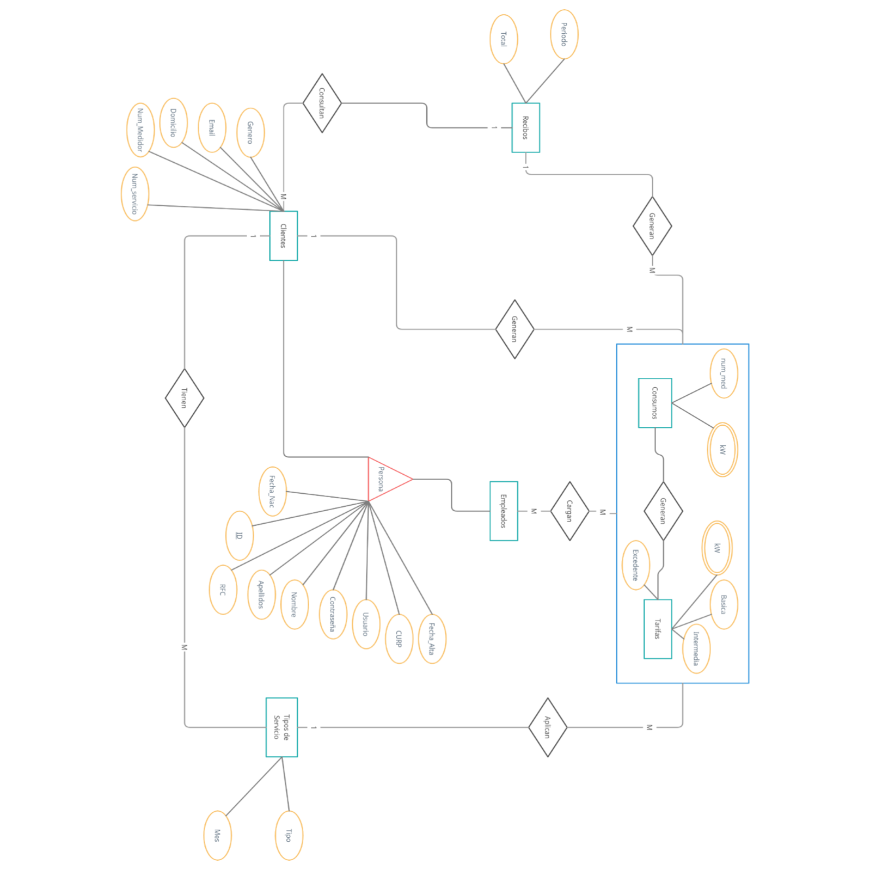

MAPEO DE DATOS

ENTIDADES

Entidad 1: users

|  |  |
| --- | --- |
| Campo | Restricción |
| ID_employees | PK, IDENTITY |
| Username | NOT NULL |
| userPassword |  |
| userType |  |
| RFC |  |
| Modification | Not Null, Default: Current Timestamp |
| isActive | NOT NULL, Default: 1 |
| IdUser | FK (users) |

|  |  |
| --- | --- |
| Campo | Restricción |
| ID_employees | PK, IDENTITY |
| Fullname | NOT NULL |
| Curp | NOT NULL |
| RFC | NOT NULL |
| Modification | Not Null, Default: Current Timestamp |
| isActive | NOT NULL, Default: 1 |
| IdUser | FK (users) |

Entidad 2: employees

Entidad 3: rememberMe

|  |  |
| --- | --- |
| Campo | Restricción |
| idUser | Not Null, FK (users) |
| userPassword |  |

Entidad 4: rates

|  |  |
| --- | --- |
| Campo | Restricción |
| Id | PK, IDENTITY |
| rateName | NOT NULL |
| rateType | NOT NULL |
| baseRate | NOT NULL |
| intermediateRate | NOT NULL |
| excedentRate | NOT NULL |
| isActive | DEFAULT: 1 |

Entidad 5: clients

|  |  |
| --- | --- |
| Campo | Restricción |
| Id | PK, IDENTITY |
| clientName | NOT NULL |
| curp | NOT NULL |
| rfc | NULL |
| streetAddress | NOT NULL |
| city | NOT NULL |
| region | NULL |
| postalCode | NULL |
| birthday | NULL |
| gender | NULL |
| isActive | DEFAULT: 1 |
| idUser | NOT NULL, FK(id) |

Entidad 6: billingPeriods

|  |  |
| --- | --- |
| Campo | Restricción |
| Id | IDENTITY, PK |
| periodNum | NOT NULL, DEFAULT: 1, Check |
| periodTxt | NOT NULL, DEFAULT: Mensual, Check |

Entidad 7: electricityMeters

|  |  |
| --- | --- |
| Campo | Restricción |
| id | IDENTITY, PK |
| regimen | FK(rates) |
| client | FK(clients) |
| billingPeriod | FK(billingPeriods) |
| isActive | NOT NULL, DEFAULT: 1 |

Entidad 8: historial

|  |  |
| --- | --- |
| Campo | Restricción |
| id | IDENTITY, PK |
| billingDate | NOT NULL |
| payed | NOT NULL, DEFAULT: 0 |
| subtotal | NOT NULL |
| subtotalPaid | NOT NULL |
| idElectricityMeter | FK(electricityMeters) |

MODELO DE DATOS

NORMALIZACIÓN DE DATOS

Para normalizar los datos, se optó por la decisión de relacionar las tablas de tal manera que todas las necesarias tengan acceso a la información del usuario; a fin de no repetir campos en múltiples tablas.

En este caso, clients y employees comparten datos que pueden no repetirse entre tablas ya que es posible que un cliente sea un empleado y viceversa. Por lo tanto, es mejor que esto se registre en el apartado de usuarios, donde todos van a estar registrados.

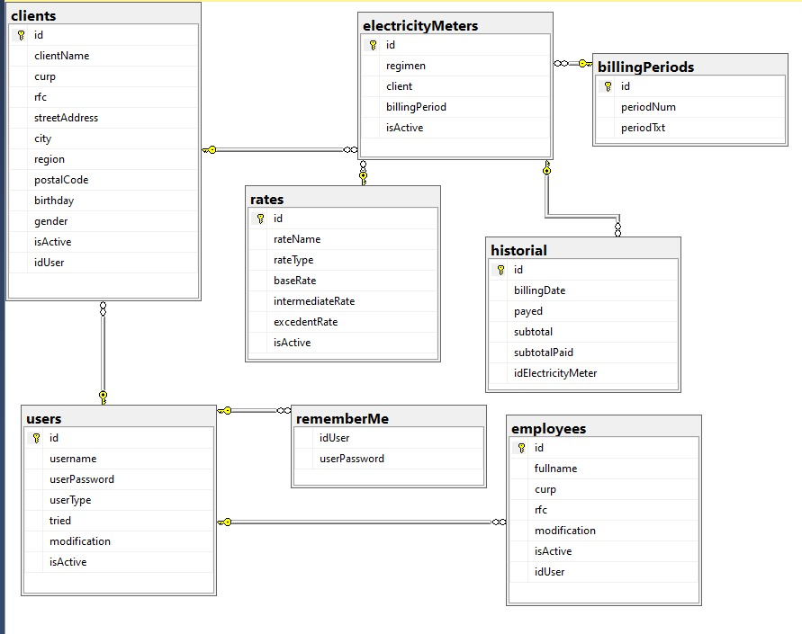 

SCRIPT CON CREACIÓN DE TABLAS

CREATE TABLE users (

id INT IDENTITY(1,1) PRIMARY KEY,

username varchar(50) NOT NULL,

userPassword varchar(50),

userType tinyint, --255 numeros

tried tinyint default 0,

modification date not null default current_timestamp,

isActive bit not null default 1

); --Entidad Fuerte

CREATE TABLE employees(

id INT IDENTITY (1,1) PRIMARY KEY,

fullname VARCHAR(100) NOT NULL,

curp VARCHAR(25) NOT NULL,

rfc VARCHAR(20) NOT NULL,

modification date not null default current_timestamp,

isActive bit not null default 1,

idUser int not null foreign key references users(id)

);

CREATE TABLE rememberMe(

idUser int not null foreign key references users(id),

userPassword VARCHAR(50)

);

CREATE TABLE rates(

id INT IDENTITY (1,1) PRIMARY KEY,

rateName VARCHAR(50) NOT NULL,

rateType VARCHAR(50) NOT NULL,

baseRate FLOAT(12) NOT NULL,

intermediateRate FLOAT(12) NOT NULL,

excedentRate FLOAT(12) NOT NULL,

isActive BIT DEFAULT 1

);

CREATE TABLE clients(

id INT IDENTITY (1,1) PRIMARY KEY,

clientName VARCHAR(100) NOT NULL,

curp VARCHAR(25) NOT NULL,

rfc VARCHAR(20) NOT NULL,

streetAddress VARCHAR(100) NOT NULL,

city VARCHAR(50) NOT NULL,

region VARCHAR(50) NULL,

postalCode INT NULL,

birthday DATE NULL,

gender varchar(10) null,

isActive BIT DEFAULT 1,

idUser int not null foreign key references users(id)

);

CREATE TABLE billingPeriods(

id INT IDENTITY (1,1) PRIMARY KEY,

periodNum tinyint not null default 1 check (periodNum = 1 OR periodNum = 3 OR periodNum = 6),

periodTxt varchar(20) not null default 'Mensual' check (periodTxt = 'Mensual' OR periodTxt = 'Trimestral' OR periodTxt = 'Semestral')

);

CREATE TABLE electricityMeters(

id int identity(1, 1) primary key,

regimen int foreign key references rates(id), -- RateType

client int foreign key references clients(id), --Name, address

billingPeriod int foreign key references billingPeriods(id), --Period

isActive bit not null default 1

); --Para la info que va a guardar cada medidor

CREATE TABLE historial(

id INT IDENTITY (1,1) PRIMARY KEY,

billingDate DATE NOT NULL,

payed BIT NOT NULL DEFAULT 0,

subtotal FLOAT(12) NOT NULL,

subtotalPaid FLOAT(12) NOT NULL,

idElectricityMeter INT FOREIGN KEY REFERENCES electricityMeters(id)

);

DIAGRAMA DE SQL SERVER



ÁLGEBRA RELACIONAL

σpostalCode => 67000 (employees)

σregion => “Nuevo León” and city = “Monterrey” (clients)

curp(clients) ∪ curp(employees)

σrfc = “MOVD990406” (clients Χ employees)

rfc(employees) ∪ rfc(clients)

|  |  |  |  |  |  |  |  |
| --- | --- | --- | --- | --- | --- | --- | --- |
|  | Atribute | is PK | Tdata Type | Accepts Null | Table | is FK | Reference |
| 1 | id | 1 | int | 0 | billingPeriods | 0 | - |
| 2 | periodNum | 0 | tinyint | 0 | billingPeriods | 0 | - |
| 3 | periodTxt | 0 | varchar | 0 | billingPeriods | 0 | - |
| 4 | id | 1 | int | 0 | clients | 0 | - |
| 5 | clientName | 0 | varchar | 0 | clients | 0 | - |
| 6 | curp | 0 | varchar | 0 | clients | 0 | - |
| 7 | rfc | 0 | varchar | 0 | clients | 0 | - |
| 8 | streetAddress | 0 | varchar | 0 | clients | 0 | - |
| 9 | city | 0 | varchar | 0 | clients | 0 | - |
| 10 | region | 0 | varchar | 1 | clients | 0 | - |
| 11 | postalCode | 0 | int | 1 | clients | 0 | - |
| 12 | birthday | 0 | date | 1 | clients | 0 | - |
| 13 | gender | 0 | varchar | 1 | clients | 0 | - |
| 14 | isActive | 0 | bit | 1 | clients | 0 | - |
| 15 | idUser | 0 | int | 0 | clients | 1 | users |
| 16 | id | 1 | int | 0 | electricityMeters | 0 | - |
| 17 | regimen | 0 | int | 1 | electricityMeters | 1 | rates |
| 18 | client | 0 | int | 1 | electricityMeters | 1 | clients |
| 19 | billingPeriod | 0 | int | 1 | electricityMeters | 1 | billingPeriods |
| 20 | isActive | 0 | bit | 0 | electricityMeters | 0 | - |
| 21 | id | 1 | int | 0 | employees | 0 | - |
| 22 | fullname | 0 | varchar | 0 | employees | 0 | - |
| 23 | curp | 0 | varchar | 0 | employees | 0 | - |
| 24 | rfc | 0 | varchar | 0 | employees | 0 | - |
| 25 | modification | 0 | date | 0 | employees | 0 | - |
| 26 | isActive | 0 | bit | 0 | employees | 0 | - |
| 27 | idUser | 0 | int | 0 | employees | 1 | users |
| 28 | id | 1 | int | 0 | historial | 0 | - |
| 29 | billingDate | 0 | date | 0 | historial | 0 | - |
| 30 | payed | 0 | bit | 0 | historial | 0 | - |
| 31 | subtotal | 0 | real | 0 | historial | 0 | - |
| 32 | subtotalPaid | 0 | real | 0 | historial | 0 | - |
| 33 | idElectricityMeter | 0 | int | 1 | historial | 1 | electricityMeters |
| 34 | id | 1 | int | 0 | rates | 0 | - |
| 35 | rateName | 0 | varchar | 0 | rates | 0 | - |
| 36 | rateType | 0 | varchar | 0 | rates | 0 | - |
| 37 | baseRate | 0 | real | 0 | rates | 0 | - |
| 38 | intermediateRate | 0 | real | 0 | rates | 0 | - |
| 39 | excedentRate | 0 | real | 0 | rates | 0 | - |
| 40 | isActive | 0 | bit | 1 | rates | 0 | - |
| 41 | idUser | 0 | int | 0 | rememberMe | 1 | users |
| 42 | userPassword | 0 | varchar | 1 | rememberMe | 0 | - |
| 43 | name | 0 | nvarchar | 0 | sysdiagrams | 0 | - |
| 44 | name | 0 | sysname | 0 | sysdiagrams | 0 | - |
| 45 | principal_id | 0 | int | 0 | sysdiagrams | 0 | - |
| 46 | diagram_id | 1 | int | 0 | sysdiagrams | 0 | - |
| 47 | version | 0 | int | 1 | sysdiagrams | 0 | - |
| 48 | definition | 0 | varbinary | 1 | sysdiagrams | 0 | - |
| 49 | id | 1 | int | 0 | users | 0 | - |
| 50 | username | 0 | varchar | 0 | users | 0 | - |
| 51 | userPassword | 0 | varchar | 1 | users | 0 | - |
| 52 | userType | 0 | tinyint | 1 | users | 0 | - |
| 53 | tried | 0 | tinyint | 1 | users | 0 | - |
| 54 | modification | 0 | date | 0 | users | 0 | - |
| 55 | isActive | 0 | bit | 0 | users | 0 | - |